Titanic Activity
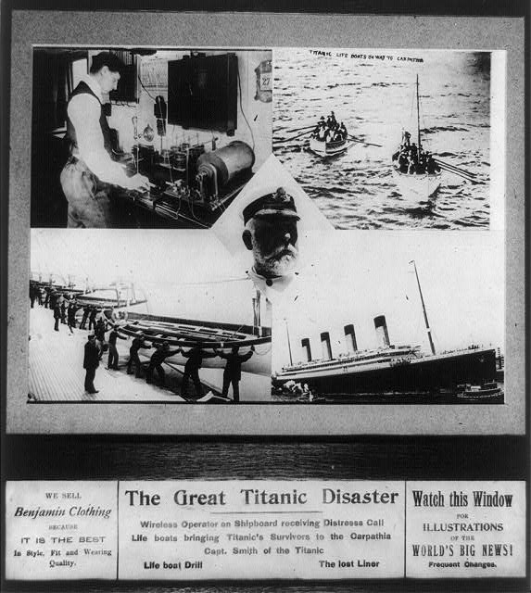

Website Exploration:
http://www.nytimes.com/learning/general/onthisday/big/0415.html
- “1,340 Perish as Titanic Sinks; Only 886, Mostly Women and Children, Rescued.” New-York tribune. (New York [N.Y.]) April 16, 1912.
- “Capt. Smith a Hero; Averted Panic, Died.” Evening bulletin. (Honolulu [Oahu, Hawaii) 1895-1912, April 19, 1912.
- “Captain E.J. Smith, of the Wrecked Titanic, and Some of New York’s Millionaires Who Honored Him.” The Hawaiian gazette. (Honolulu [Oahu, Hawaii]) April 23, 1912.
- “Titanic Tragedy was Criminal and Needless.” Evening bulletin. (Honolulu [Oahu, Hawaii) April 26, 1912.Continues, page 6:“Official story of the Great Disaster.”
- “Denies He Saw Titanic Go Down.” The Mathews journal. (Mathews C.H. [Court House]) May 02, 1912.
- “Main Points in Senate Titanic report.” The Washington times. (Washington [D.C.]) May, 28, 1912. Continues, page 7
- “Arraigns J. Bruce Ismay and the White Star Line Officials.” Perrysburg Journal. (Perrysburg, Wood Co., O. [Ohio]) May 31, 1912.

Website Questions: (analyze two articles)

- What is the name of the article? Date?

- Who is the Author? What Newspaper was the article published in?

- What is the topic of the article?

- What arguments does the author make?

- Is the article biased in any way?

